**DAILY ONLINE ACTIVITIES SUMMARY**

|  |  |  |  |  |  |  |  |  |
| --- | --- | --- | --- | --- | --- | --- | --- | --- |
| **Date:** | **3 JULY** | | | | | **Name:** | **Shah Dhruvil Amit** | |
| **Sem & Sec** | **6th Sem ‘B’ Sec** | | | | | **USN:** | **4AL17CS083** | |
| **Online Test Summary** | | | | | | | | |
| **Subject** | |  | | | | | | |
| **Max. Marks** | | **--** | | **Score** | | |  | |
| **Certification Course Summary** | | | | | | | | |
| **Course** | **Placement Training** | | | | | | | |
| **Certificate Provider** | | |  | | **Duration** | | |  |
| **Coding Challenges** | | | | | | | | |
| **Problem Statement: 1 program** | | | | | | | | |
| **Status: Executed** | | | | | | | | |
| **Uploaded the report in GitHub** | | | | | **yes** | | | |
| **If yes Repository name** | | | | | <https://github.com/DhruvilShah99/Daily-Updates> | | | |
| **Uploaded the report in slack** | | | | | **yes** | | | |

**WEBINAR :-**

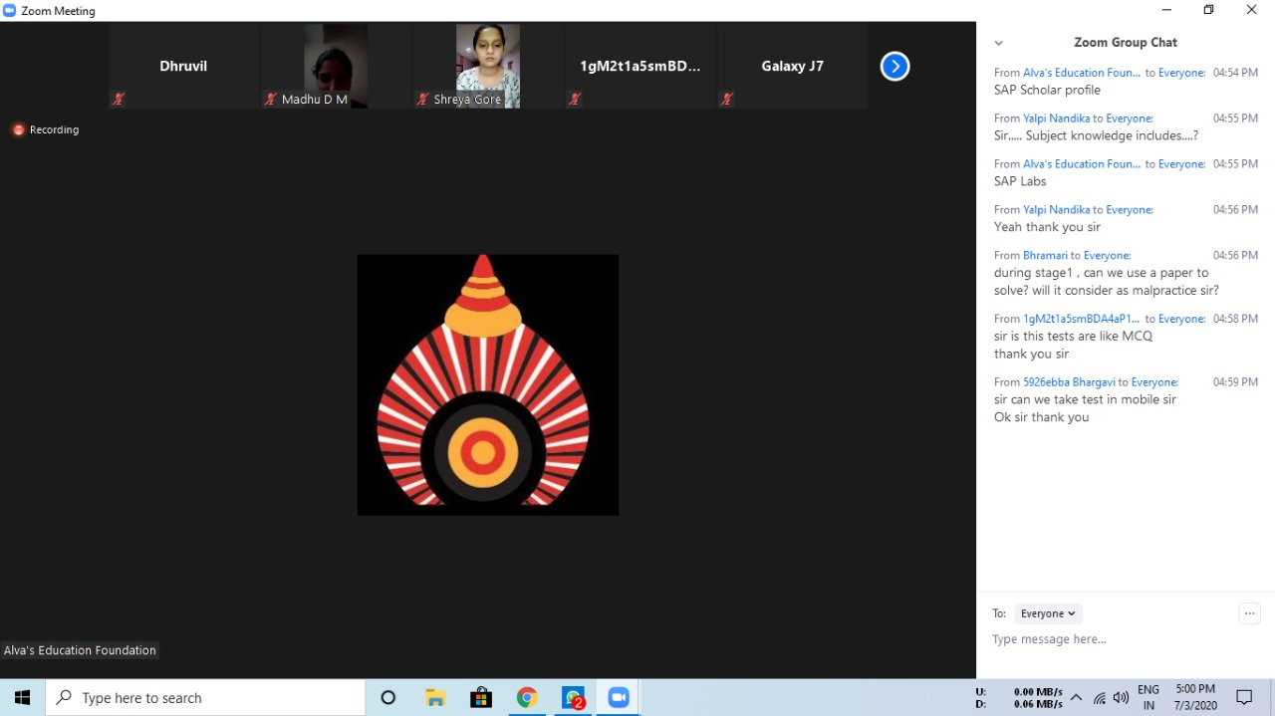

**Coding Challenges Details:**

2 JULY – Code: Positive and negative real no

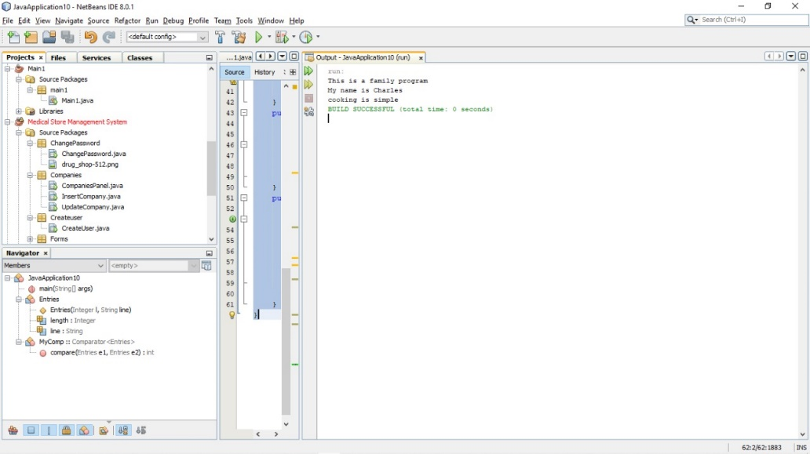

**1-For Report and daily coding challenges** 🡪

<https://github.com/DhruvilShah99/Daily-Updates>